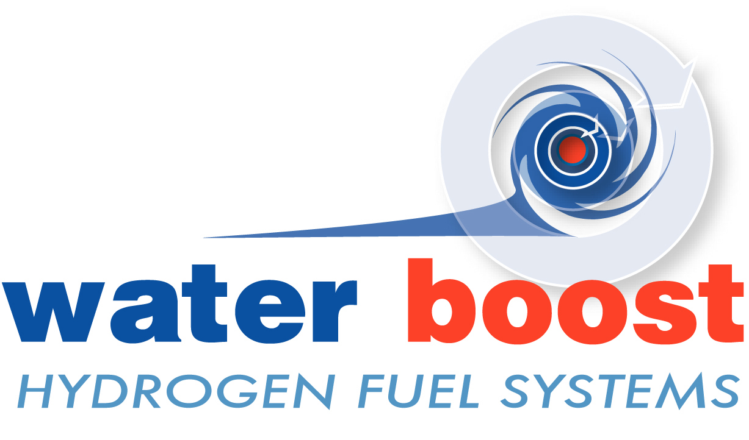

Waterboost Manual
Hydrogen Fuel Injection System

The Water Boost System uses electricity from your cars alternator to generate Hydrogen and Oxygen gas from water.
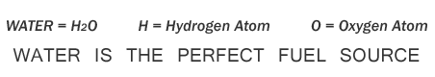
The results are astounding, more torque at lower engine speeds, lower emissions, cooler engine, less carbon build up and considerably more miles per gallon.
Document Description: Owners Manual
On Demand system for the production of Hydrogen and Oxygen gas for internal combustion engines...

What is a Waterboost System?
The Waterboost System creates Hydrogen and Oxygen from water. The gases are generated on demand using an electrolysis cell fitted to a vehicle. The Hydrogen and Oxygen gas can be injected into any internal combustion engine via the air inlet manifold. The electricity required to run the unit is usually not much more than that required to power your headlights.

What will a Waterboost System do?
By promoting a more complete burn the system keeps engine lubricants cleaner. Most vehicles experience a noticeable increase in horsepower. Combustion is simply more powerful, resulting in more torque and general output from your engine. The level of reduced emissions depends on the vehicle and its existing fuel system.

Incomplete combustion causes a build up of carbon deposits in the engine. The unit stimulates the combustion process to help eliminate existing deposits and prevent future carbon build up. The result is a reduction of abrasion and wear of pistons, rings, valves, cylinder walls and overall degradation of the engine and its oils.

Injecting Hydrogen and Oxygen allows vehicles to be run at exceptionally high air to fuel ratios (e.g. 18:1) without the inherent misfire, the system also reduces emissions, reduces fuel consumption and improves engine performance.

Transition from fossil fuels to renewable hydrogen by use of mixtures of hydrogen in small quantities with conventional fuels offers significant reductions in exhaust emissions. Using hydrogen as a combustion stimulant makes it possible for inferior fuels to meet future requirements for lower exhaust emissions.

Waterboost Installation
Installation of the system is simple and can take as little as half a day.

What about Manufacturers Warranties and Insurance Companies?
The system will not affect any manufacturer’s warranties and should not be considered a performance upgrade or an additional security risk by the insurance companies.

How does the Waterboost System make such a big difference?
The Waterboost Unit produces 1 litre per minute of Hydrogen and Oxygen at 20amps. The Hydrogen and Oxygen produced by the unit results in faster rates of initiation and subsequent propagation of flames across the whole combustion range. The enhancement of flame initiation and subsequent flame propagation reduces the Ignition delay and combustion period in both spark ignition (eg. Petrol) and compression ignition (eg. Diesel) engines.

The chain reaction initiated by the Hydrogen and Oxygen will cause a simultaneous ignition of all the primary fuel. As it all ignites at once, no flame front can exist and without it there is no pressure wave to create knock. Unburned hydrocarbons, CO and NO, in the exhaust are either eliminated or drastically reduced and at the same R.P.M. the engine produces more torque from less fuel.

The near absence of carbon monoxide and unburned hydrocarbons confirms a very complete and much faster burn. Cooler exhaust temperatures show that more work is taken out during the power stroke. More torque from less fuel at the same engine speeds verifies that higher pressure from a faster burn, acting through a longer effective power stroke, produces more torque and thus more work from less fuel.

The enhanced fuel/air/hydrogen/oxygen mix burns up to 10 times faster however this rapid burn is so fast that the resulting power stroke and exhaust stroke will be much cooler, resulting in significantly less nitrous oxides (NOx)

Almost all unburned hydrocarbons, CO and NO, are eliminated. Reducing hydrocarbons and CO causes a slight rise in the percentage of CO2 in the exhaust, but as less fuel is used, the actual quantity of CO2 produced is reduced by roughly the same ratio as the savings in fuel. In brief, noxious gas is almost eliminated and greenhouse gas is decreased in proportion to the reduction in fuel consumption.

Hydrogen burns more rapidly than hydrocarbon fuels because it is smaller and enters combustion reactions at higher velocity, has lower activation energy, and incurs more molecular collisions than heavier molecules. These characteristics make it possible to use mixtures of hydrogen with conventional hydrocarbon fuels such as gasoline, diesel and propane to reduce emissions of unburned hydrocarbons.

“Higher pressure from a faster burn, acting through a longer effective power stroke, produces more torque and thus more work from less fuel”

Waterboost Kit
The Waterboost System includes the following:
1 - a waterboost gas unit
2 - relay 100amp
3 - 50amp fuse and holder
4 - shunt
5 - blue lcd backlit digital display
6 - isolated power chip for display (not shown)
7 – 3 piece gas fitting/connector
8 - 2 metres of polyurethane 8mm tube (not shown)

(The numbers correspond to the numbers shown on the picture below)

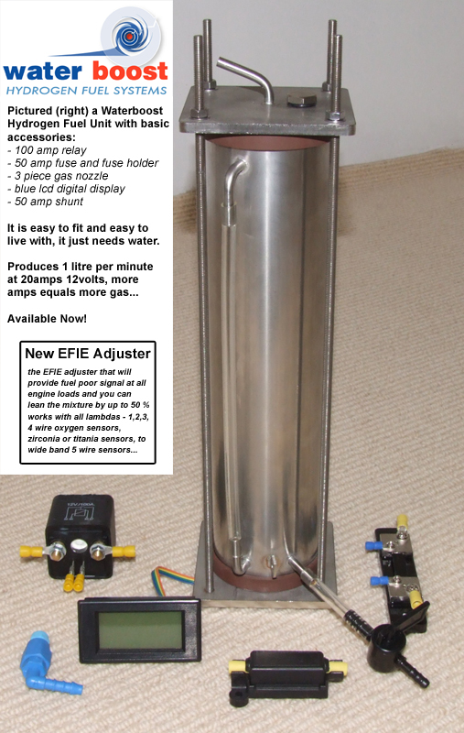
Waterboost Extras
EFIE Lambda (Oxygen Sensor) Adjuster
The EFIE Lambda Adjuster has been developed for engines with Waterboost Systems Installed. Injecting Hydrogen and Oxygen increases the level of oxygen in the exhaust, the result is the vehicle computer sending more fuel that is not needed. The unit tricks the vehicle computer into thinking there is less oxygen in the exhaust than there actually is; the signal is fully adjustable to accommodate different vehicles.

The EFIE adjuster that will provide fuel poor signal at all engine loads and you can lean the mixture by up to 50 %. Works with all lambdas - 1,2,3,4 wire oxygen sensors, zirconium or titanium sensors... If you have 2 oxygen/lambda sensors then you will need 2 adjusters, one for each sensor.

EFIE MAP/MAF Sensor Adjuster
1
2
The EFIE MAP is designed only to be used in conjunction with fuel saving technologies that increase fuel combustion efficiency. The EFIE MAP modifies the voltage signal from the MAP or MAF sensor and then outputs the ‘new’ signal to the vehicle computer (ECU) – The voltage offset is fully adjustable to suit your particular vehicle and the vehicle computer will no longer be able to prevent efficient combustion!
4
5
7

3

Waterboost Installation Recommendations:
Before starting installation (READ DISCLAIMER):
- If you are not 100% sure of what you should be doing, we strongly recommend asking an automotive electrician to complete the wiring to ensure no damage can occur to your electrical systems.
- Read the instructions thoroughly before beginning installation
- Ensure you have adequate space for the main unit, as close to the air intake as possible.
- The Waterboost Unit should be securely mounted and clear of any moving parts. A small bracket may be required in some circumstances (not supplied)
- The manufacturers and retailers of Waterboost Systems accept no legal responsibility, under any circumstances, for loss or damage of any kind, caused during or after installation of a Waterboost System.
- You should ensure that the correct gauge of wire is used, the right connectors and all connections are tightly fastened and components installed in a reasonably dry position away from hot, moving parts.
7) If you have any queries, are vaguely unsure about anything, don’t take any chances, email us immediately at: queries@waterboost.co.uk or visit http://www.waterboost.co.uk
Installation Diagram for
Waterboost System
Please fully familiarise yourself with all of the components before starting the installation. Fit the components to the vehicle before wiring them together. Keep your wiring tidy and neat…

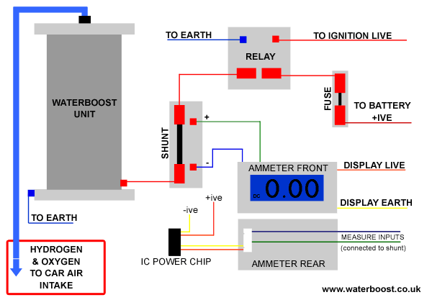

Setting up your Waterboost Unit
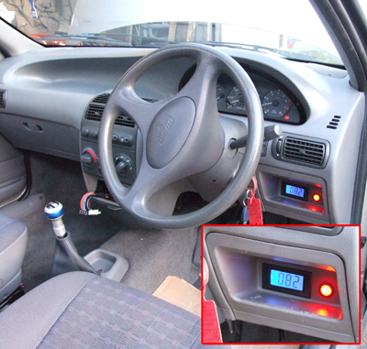
Before turning on your Waterboost Unit for the first time, you must have all of the components installed correctly. Add a level teaspoon of caustic soda (NaOH) to 1.5 litres of water (see notes below on water quality…)

Shake the mix for a minute and let it settle. Always add caustic soda to water, never the other way around.

Add the mix to the unit, until the water reaches the top of the viewer tube on the side.

Start the car, with the unit switched on; check the reading on the ammeter. The Waterboost unit works very efficiently between 10-20 amps. Whatever the reading is when you turn the unit on from cold, it will roughly double over a long journey. A good place to start is between 8 and 11 amps. Most vehicles would prefer it if you stay below 25 amps.

If you want the unit to use more amps, add more water with the caustic soda mix, if you are happy with the amps, you can just use water to keep it topped up. The caustic water (electrolyte) is only needed very rarely after the initial set up procedure. If you added too much caustic and your unit wants too many amps, drain some water off using the drain tap and add pure water. Take care handling caustic water and store appropriately.
Water Quality
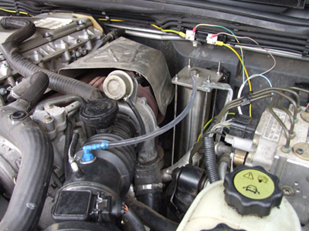
Water quality varies immensely. Although we use tap water we have found that in some regions the tap water contains too many contaminants and iron oxides which will damage your Waterboost Unit. If you see any discolouration, stop using your unit, clean it through thoroughly and make a note of what nasty water caused the problem. Contamination is the only way to ruin your Waterboost, it is your responsibility. We can take no responsibility for damage caused by contaminants in your water, so please choose your water carefully. We recommend quality water. Distilled water is very good, Purified water is excellent. Special Note: “Not all bottled waters are the same.”

NOTICE: The blue gas connector should be fitted after the air flow sensor

Final Vehicle Adjustments
After successful installation of your system we recommend you run your vehicle for a week or two and see how the car runs, mpg, etc.

On old cars the system should work as expected, however newer cars suffer from annoying sensors. As the vehicle combustion efficiency increases, the vehicles computer senses the change and does everything it can to waste fuel.

EFIE MAP and EFIE Oxygen adjusters are available as extras to ensure you have full control of your new fuel saving technology. Both adjusters allow the vehicle to run leaner and stop the vehicle computer from preventing efficient combustion. Contact Waterboost or your nearest retailer for more information.

Waterboost Disclaimer
The manufacturers and retailers of Waterboost Systems accept no legal responsibility, under any circumstances, for loss or damage of any kind, caused during or after installation of a Waterboost System.

REMINDER: Contamination is the only way to ruin your Waterboost, it is your responsibility, and we take no responsibility for damage caused by contaminants in your water, so please choose your water carefully. We have run these units continuously for over 12 months with no adverse effects, discolouration or corrosion.
“The installation notes are not meant to be complete fitting instructions, just a quick guide for each component used in the system. Every car is different and may require a slightly different approach. Take your time, do it properly, think it through and it should be easy.”

Installation Notes:
1) Ensure the Waterboost unit is fitted securely, clear from moving components and that the unit does not prevent access to other vital engine components. Always mount your waterboost unit vertically… NOT AT AN ANGLE – The threaded bars running the length of the unit are normally used to mount the unit to a suitable bracket. It also needs to be easy to access the filler cap on the top of the unit and to clearly see the water level viewer on the side.
Remember: The centre tube is live! Make sure it does not touch anything else.

2) Always use high current rated connectors and wire. 30amp minimum…

3) The relay should be mounted so that it sits vertically, mounted using the bracket on the top of the relay casing.

4) The relay, shunt and fuse should be mounted somewhere dry. Under the bonnet is fine unless you drive through rivers regularly.

5) The digital display needs to be somewhere you can see it without distracting you from your other clocks and so you can see it safely whilst driving, without altering your driving position.

6) The 3 piece connector can be used as a one piece connector if you have a ridged area to drill and tap, after the air flow meter. If not, drill a hole in the rubber intake hose, after the air flow meter and fasten the top piece into the bottom 2 pieces whilst holding them inside the rubber intake hose. Make sure they are tight and cannot come loose. Use a large washer on both sides if the intake hose is very weak and/or floppy.

7) The polyurethane pipe may need to warmed/heated with a small flame or hot water to ensure it fits on the end of the blue 3 piece fitting. Extending the drain tap will also require a little heat.

8) Change your oil and filters… if the oil still looks black straight away, change them again.

9) Emissions check the vehicle; make sure it isn’t running to rich (petrol only) – Run the vehicle in by doing some long motorway driving (all vehicles)… when you are sure the car is running cooler, it is time to consider trying a MAF/MAP adjuster or Lambda/Oxygen adjuster to lean the vehicle off and see some real mpg gains.

Modern diesels and nearly all petrol cars have oxygen sensors which prevent efficient combustion, the adjusters will allow you to stop them from wasting your fuel. Older petrol cars can be adjusted by a mechanic with a simple screwdriver on most vehicles that use a carburettor. If your radiator fan never comes on, your car is running cool and can be adjusted to use much less fuel.

The reason we ask you to run the vehicle in first, is to ensure the hydrogen and oxygen have had chance to clear out the carbon build up in the engine. Carbon build up creates hot spots that make your car run too hot and more fuel is needed to cool it down. If you reduced the level of fuel without clearing the cars pipes you could run a small risk of engine damage, however we haven’t managed to damage an engine and we have tried really hard!

10) Finally, thank you for purchasing a Waterboost System. As well as a fuel saving device it helps to reduce harmful emissions and increases the oxygen levels your car produces. Carbon Dioxide is fuel for plants, its is NOX and Carbon Monoxide that poison our environment and your Waterboost System can almost eliminate the production of these noxious gases. Any profits from the sale of these units will be used to fund ongoing research into new fuel technologies and off-grid solutions.

